RESOLUTION NO. 2024-01-29-1

A RESOLUTION IN SUPPORT OF THE PERMIAN BASIN METROPOLITAN PLANNING ORGANIZATION’S PROJECTS IN THE 2025 TXDOT
UNIFIED TRANSPORTATION PROGRAM

WHEREAS, pursuant to federal law, the Governor of the State of Texas designated the Permian Basin Metropolitan Planning Organization (PBMPO) as the Metropolitan Planning Organization for the Midland - Odessa region; and

WHEREAS, PBMPO's Policy Board is the entity for cooperative decision making regarding regional transportation issues in portions of Midland, Ector and Martin Counties; and including the cities of Midland and Odessa; and

WHEREAS, the Texas Department of Transportation (TxDOT) is a valuable partner in planning for and implementing the region's mobility needs; and

WHEREAS, TxDOT's Unified Transportation Program (UTP) is a 10-year planning guide for transportation project development and construction that is updated annually; and funding category allocations for the 2025 UTP include input from Metropolitan Planning Organizations and other stakeholders; and

WHEREAS, the 2025 UTP includes funding sources such as TxDOT Category 2 funds made available for MPO projects; additional funding provided through the federal IIJA transportation bill for metropolitan and rural areas in the state; and funding for the state's connectivity corridors; and

WHEREAS, projects listed in Attachment “A” are part of this Resolution and are prioritized using the PBMPO’s approved project selection process. All projects are also listed in the 2045 MTP. The projects listed are intended to maximize the use of available funding by leveraging additional funding sources.
NOW, THEREFORE BE IT RESOLVED that the Permian Basin Metropolitan Planning Organization's Policy Board recommends the attached list of regional projects to be included in the TxDOT FY 2025-2034 UTP, leveraging MPO directed funding from Category 2 with local funding sources and Commission directed funding.

PASSED AND APPROVED this 29th day of January 2024
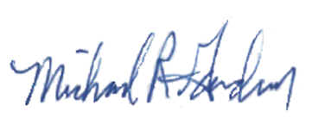
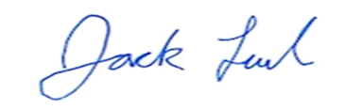

____________________________________ __________________________________ Jack Ladd, Chair Mike Gardner, Vice Chair
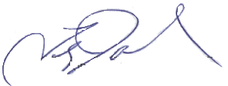
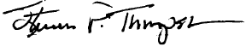

____________________________________ __________________________________
Steve Thompson Terry Johnson
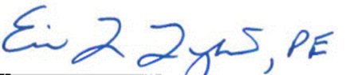

____________________________________ __________________________________
Eric Lykins, P.E. Bryan Cox

ATTACHMENT “A”

The projects listed below are in priority order. Funding indicated is from Category 2.
- Add funding to the US 385 at South Loop 338 to account for updated cost estimate - $7M
- Add the widening of SH 158 from Wadley to Briarwood -$5M
- Construct a new interchange at Loop 338E at 87th Street - $12.5M
- Construct a new interchange at BI-20 at Faudree – $5.5M (partially funded)
- Intersection improvements & ramp reconfiguration on Loop 250 from Midland Dr. to W. of Midkiff - $5M
- Construct a new interchange on SH 191 at CR 1250 - $5M (partially funded)

Proposed changes to existing projects in the 2024 UTP are as follows:
  - Reduce funding for the interchange on Loop 338 E at 52/56th Streets from $28M to $5.5M
= gain of $22.5M to be added to project 3 above – LP 338 @87th Street providing $35M total
  - Change description of “Upgrade to Freeway” in the current UTP for a portion of LP 338E to ”Construct Frontage Roads” from Yukon Road to US 385N - $36.236M – no change in funding

Total = $40,000,000
